Principal:
Karena Munroe

Assistant Principal
Martin Andreasen

Grade 6 | Supply List

School Supply List
Basic disposable supplies, (pencils, erasers, exercise books, paper, glue, and duo tangs), will be provided for all Grade 6 students for use while at school. The following is a list of recommended supplies that parents are recommended to purchase for Grade 6 students at DTS.

- One 3” zippered binder  - Colored binder dividers (blue/green/pink/yellow)  - French/English dictionary  - Pencil Case  - Agenda (optional)  - Geometry set (optional)  - Basic Protractor (no hole, see picture below)  - Ear buds/Headphones  - Water bottle  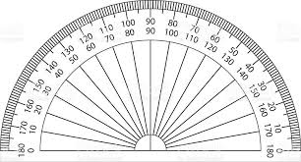 | - Highlighters x2  - Pencil sharpener  - 30 cm Ruler  - Backpack  - Pair of athletic running shoes for PE (NO Toms, Slides, or Crocs please)  - Bescherelle Poche Conjugaison (French language verb reference book)  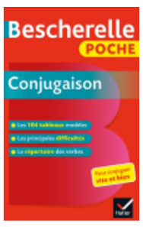
Please ensure that everything is labelled with the student’s name.

